Python Calculator

一、組員：莫均朗、許為傑、林哲宇

二、系統簡述：

(內容參照github網頁上的README.md推薦助教在網頁排版較容易閱讀[點我連結](https://github.com/CCUXMultiMedia2016Spring/Multimedia_402530018_1))

**Important!! Run in python3X or later**

**[Class] Calculator:**

Quick view:

Calculation logic

Button clicked event

Store number for Calculation

Variables:

current:

current number use to calculate.

store:

store number to be op with the next current.

new_num :

if the number is new, put the current into store.

combo:

execute using two ops. ex: 2+2 '+'

op:

store operation

Method:

num_press(num)

accept parameters : numbers

oper(op)

accept parameters : '+', '-', '\*', '/'

execute()

execute with 'store' 'op' 'current' pattern, and save the result to [ResultBox].

final()

trigger while '=' is clicked.

display(number)

display number to [text_box].

clear()

C button,clear current

all_clear()

AC button

**[Class] ResultBox:**

Quick view:

Result box logic

Variables:

none

Method:

clicked(event)

trigger when user clicked on a list item, should be bind with <ButtonRelease-1>.

clear()

clear the result box

三、系統流程圖

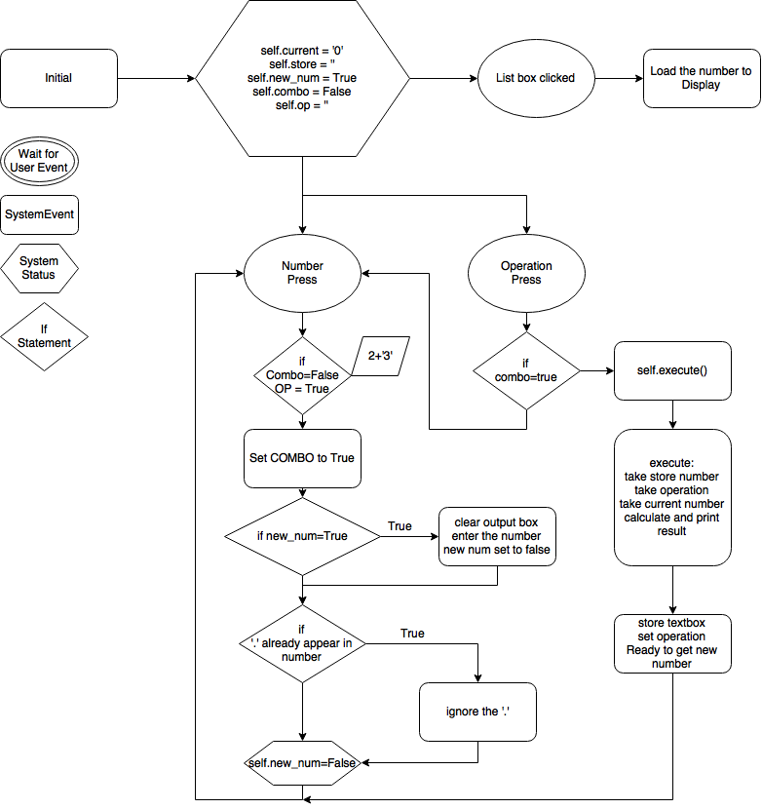

四、使用流程

Step 1

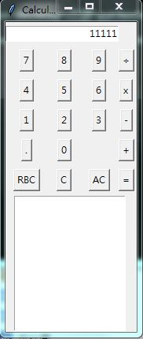

Step 2

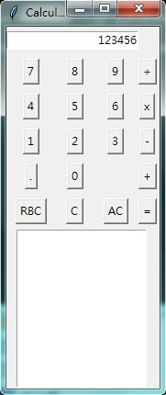

Step 3

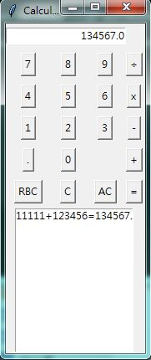

Step 4

